
Lower Darwen Primary School.
Supporting Children and Families with Special Educational Needs.
The aim of this booklet is to support you in understanding the process we follow to support all children at Lower Darwen Primary School. If you have any worries or concerns about your child, please speak to your child’s class teacher.
Within this booklet, we have identified and explained the process we go through to ensure we all meet your child’s needs. The booklet also explains the roles of the professionals we may refer your child to.
If you have shared a concern with us about your child, there are different pathways we follow to ensure we meet your child’s need.
As a school, we are here to make it right for every child and strive to ensure that they get the best education possible for them.
Please feel free to talk to us about your child by making an appointment by contacting the school office via telephone on: 01254 55639 or email at: office@lowerdarwen.blackburn.sch.uk

SEND Code of Practice:
The SEND code of practice is an official government guide for teachers who work with children who have Special Educational Needs and Disabilities (SEND). It focuses on a family centred system of care and education. The document provides statutory guidance on duties, policies and procedures. It is in place to support children and young people with Special Educational Needs (SEN) and disabled children and young people under the age of 25 years.
The statutory code contains:
- Details of legal requirements that must be followed.
- Statutory guidance that must be followed by law.
- It explains the duties of local authorities, health bodies, schools and colleges to provide for those with special educational needs under part 3 of the ‘Children and Families Act, 2014.’ A code followed by all professionals.

Everyone at Lower Darwen Primary School is committed to putting the children first. We aim to create a learning environment where all children in our care enjoy coming to school and make the best of all of the opportunities offered to them.
Identifying children who need further support:
Early identification of need is paramount to ensure that children do not fall behind with their academic studies or lose their self-esteem. Many children experience difficulties at different times in their lives and it is important that any difficulties are identified and supported in the best way possible.
There are four broad categories of need. The purpose of identifying which category applies to a child is to work out what action we need to take, not to ‘label’ the child or to fit them into a category. We endeavor to always consider the needs of the whole child.
The four categories of need:
- Communication and Interaction.
- Cognition and Learning.
- Social, emotional and mental health (SEMH).
- Physical and sensory.

When a child needs individual provision, above and beyond other children, then they are placed onto the school’s SEND register (with parental permission). We use a self-evaluation inquiry processes to create a provision map. This details adjustments that we as a school will make in order to meet the needs of all of the children.
If there are immediate concerns about a child’s learning and development, these will be acted upon straight away and further support requested from relevant agencies and professionals.
Where a child’s baseline is a cause for concern, then these children will be closely monitored and their learning, development and progress reviewed more frequently; to establish what appropriate next steps might be needed.
All staff have a responsibility to listen carefully to children’s voices and to regularly observe children.

Graduated Approach for all children:
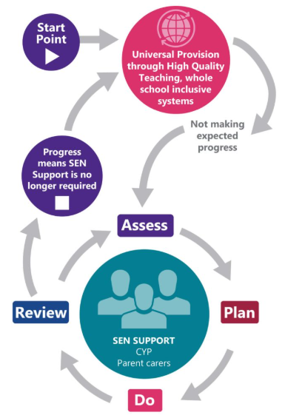

- Assess: Observations / assessments undertaken by the SENDCO identifying strengths and areas to target. Interventions / strategies suggested and the child will be monitored with new strategies put in place. This may include a referral to other services but this would be a decision made alongside parents.
- Plan: Child monitored and added to the SEND register. Teachers will implement the strategies / information provided, including the outcomes outlined within an EHCP. They will generate a SEND Support plan (STAR plan) which will be shared with parents.
- Do: Class teachers will modify teaching, plan learning activities and provide for the needs of all of the SEND pupils within their class. The class teacher will remain responsible for working with and supporting the child or young person on a daily basis.
- Review: SEND support plans (STAR plans) will be monitored and evaluated by staff and parents. Additional support / further advice and assessment from external services may be requested. A decision will then be made as to remove a child from the SEND register, remain at SEND support or consider an application for an EHCP.
SEND Support Plan (STAR Plan):
A STAR plan will detail smaller identified targets linked specifically to your child’s learning and development. These are to be worked on at home as well as in school and will be reviewed termly. If children achieve these targets sooner, then they will be adapted and changed when necessary.

The WAVE approach:
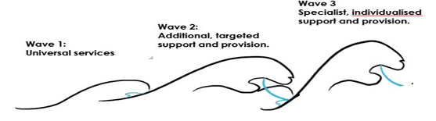
The WAVE approach is a way of showing the graduated response to children and the pathways that we follow to support their individual needs. As children need above and beyond the curriculum being taught they will then move on to the next WAVE.
WAVE 1: Universal services:
All children have access to a broad and balanced curriculum, their progress will be monitored and assessed through the developmental levels of:
- Class based assessments (e.g. WhiteRose, Letters and Sounds).
- Daily lesson observations.
Teachers will liaise with parents / carers to discuss their child’s achievements and progress. This can be shared through:
- Formal parent’s evenings.
- Annual year report.
- Appointments made via the office.
WAVE 2: Additional, targeted support and provision:
If a child has been assessed and is working developmentally lower than those of their chronological age or are not making progress, then the SENDCo. will consider moving to WAVE 2. This means that the SENDCo. will introduce the following measures to support the child;
- Targeted activities or one to one time in session focusing on the specific needs of the individual child.
- Planned / targeted interventions.
- Targeted resources or adjusting the environment if needed.
WAVE 3: Specialist, individualised support and provision:
Children who have an unmet additional need will be at WAVE 3. At this stage, children will be monitored through a SEND support plan (STAR plan). STAR plans are written by the child’s class teacher with support from the SENDCO, parents and child. These plans are evaluated termly and next steps are then determined. If a child meets the targets earlier than this, then they are amended at the relevant time. Other professionals’ reports are used to influence the targets being set.

Professionals and their roles:
It is important that we use the skills and knowledge of all professionals and to build on each other’s strengths. We do this to ensure that your child is getting a well-rounded and inclusive approach and is able to gain the best education they can. Some of these professionals are:
- SEND Support Service.
- Educational Psychologists.
- Community Pediatricians.
- A CAF and TAF process.
- Speech and Language therapy.
- Occupational therapy.
- Mental Health Support Team.
- Educational Health and Care Plan Process.

