Pupil Premium Strategy Statement – Lower Darwen Primary School

This statement details our school’s use of pupil premium funding to help improve the attainment of our disadvantaged pupils.
It outlines our pupil premium strategy, how we intend to spend the funding in this academic year and the outcomes for disadvantaged pupils last academic year.

School overview
Detail | Data
Number of pupils in school | 378
Proportion (%) of pupil premium eligible pupils | 20%
Academic year/years that our current pupil premium strategy plan covers | 2025-26
Date this statement was published | 31st December 2025
Date on which it will be reviewed | 31st December 2026
Statement authorised by
Pupil premium lead | Kerry Murray
Governor / Trustee lead | Emily Taylor

Funding overview
Detail | Amount
Pupil premium funding allocation this academic year | £111,925
Pupil premium funding carried forward from previous years (enter £0 if not applicable) | £0
Total budget for this academic year  If your school is an academy in a trust that pools this funding, state the amount available to your school this academic year | £111,925

Part A: Pupil premium strategy plan

Statement of intent
At the heart of our pupil premium strategy is a fundamental commitment: vulnerable pupils come first. We believe that all disadvantaged learners should receive targeted, high-quality support designed to remove barriers, unlock opportunities and enable them to flourish academically, socially and emotionally.
Our approach challenges myths and low expectations by fostering a culture of no limits — where pupils are encouraged not just to reach their potential, but to exceed it. We reject deficit narratives and fixed mindsets. Instead, we cultivate ambition, resilience and a growth mindset so every child can aspire to and achieve excellence.
We prioritise building cultural capital to broaden pupils’ horizons, enabling access to enriching experiences that develop confidence, curiosity and social mobility. This, alongside rigorous academic support and pastoral care, addresses the multifaceted nature of disadvantage, including the often-hidden barriers that may impact learning but are less visible.
Our strategy is firmly aligned with the Education Endowment Foundation’s guidance, ensuring that all interventions are evidence-informed and regularly evaluated for impact. High-quality teaching remains the greatest lever for change, complemented by targeted academic support and wider strategies addressing attendance, wellbeing and family engagement.
Through precise assessment, robust monitoring and a whole-school commitment to equity and inclusion, we aim to close attainment gaps sustainably and equip our disadvantaged pupils to succeed as confident, capable learners and positive contributors to society.

Challenges
This details the key challenges to achievement that we have identified among our disadvantaged pupils.
Challenge number | Detail of challenge
1 | Communication and Language  EYFSP data for 2024-25 shows a significantly disproportionate gap of -42.9% in attainment in communication and language between our disadvantaged pupils and their peers and a gap of -21% compared to comparisons across the LA.
2 | Physical Development in EYFS  EYFSP data for 2024-25 shows a significantly disproportionate gap of -42.9% in attainment in physical development between our disadvantaged pupils and their peers and a gap of -27.2% compared to comparisons across the LA.
3 | Personal, Social and Emotional Development in EYFS  EYFSP data for 2024-25 shows a significantly disproportionate gap of -38.1% in attainment in personal, social and emotional development between our disadvantaged pupils and their peers and a gap of -10.7% compared to comparisons across the LA.
4 | Literacy in EYFS  EYFSP data for 2024-25 shows a significantly disproportionate gap of -42.9% in attainment in literacy between our disadvantaged pupils and their peers and a gap of -21% compared to comparisons across the LA.
5 | Attendance  This academic year, a disparity between attendance rates has been observed between Pupil Premium and non-Pupil Premium students. Pupil Premium children recorded an average attendance of 93.8% whilst non-Pupil Premium children achieved a higher attendance rate of 95.1%.
6 | Behaviour  Behaviour monitoring data shows that Pupil Premium pupils account for 65% of all incidents of negative behaviour since September 2025.This highlights a disproportionate representation within this group. Also, exclusion data shows that all exclusions recorded during the reporting period relate to pupils in receipt of the Pupil Premium.

Intended outcomes
This explains the outcomes we are aiming for by the end of our current strategy plan, and how we will measure whether they have been achieved.
Intended outcome | Success criteria
EYFS Pupil Premium children’s attainment in:  - communication and language  - physical development  - social and emotional development  - literacy  is brought in line with, or exceeds, that of their non-disadvantaged peers. | - The attainment gap in communication and language between disadvantaged pupils and their peers is reduced from –42.9% to at least –0% by the end of the academic year.  - The attainment gap in physical development between disadvantaged pupils and their peers is reduced from –42.9% to at least –0% by the end of the academic year.  - The attainment gap in personal, social and emotional development between disadvantaged pupils and their peers is reduced from –38.1% to at least –0% by the end of the academic year.  - The attainment gap in literacy between disadvantaged pupils and their peers is reduced from –42.9% to at least –0% by the end of the academic year.
Improved attendance rates of Pupil Premium children so that their attendance is consistently in line with or exceeds that of their peers. | - Pupil Premium attendance rate improves to at least 95%, matching or exceeding the attendance rate of non-Pupil Premium peers.  - Reduction in persistent absenteeism among Pupil Premium pupils by at least 10% within the academic year.  - Increased engagement with families, evidenced by at least 90% of targeted families attending attendance-related meetings or interventions.  - Regular attendance monitoring and timely interventions lead to improved attendance within 4 weeks of identified issues.
Incidents of negative behaviour among Pupil Premium pupils significantly reduced from 65% to in line with their peers through the implementation of targeted behaviour support strategies, restorative practices and positive reinforcement systems. . | - A reduction in recorded negative behaviour incidents involving Pupil Premium pupils from 65% to below 30% by the end of the academic year.  - Increase in the number of positive behaviour referrals for Pupil Premium pupils by at least 30%.  - Decrease in fixed-term exclusions for Pupil Premium pupils by at least 50%.  - To foster a more inclusive and supportive learning environment, leading to improved engagement, wellbeing and academic outcomes for these pupils  - Improved pupil self-regulation skills, demonstrated by at least 80% of targeted pupils showing progress in behaviour logs.  - Regular monitoring shows a reduction in repeat behaviour incidents within targeted pupils after interventions, with at least 70% maintaining improved behaviour over a 6-week period.

Activity in this academic year
This details how we intend to spend our pupil premium funding this academic year to address the challenges listed above.

Teaching (for example, CPD, recruitment and retention)
Budgeted cost: £55,962
Activity | Evidence that supports this approach | Challenge number(s) addressed
Developing high quality teaching, curriculum and assessment  - Embed consistent, evidence-based classroom strategies (HQITF) to support all learners inc. PP pupils.  - Development of Teaching and Learning Handbook to ensure a common language around shared teaching techniques and routines – ensuring students have common expectations in lessons  - Feedback to teachers on classroom practice from middle leaders and SLT which is used to inform whole school training | The EEF’s Teaching and Learning Toolkit, which summarises a large body of international evidence, rates ‘metacognition and self-regulation’ as a high-impact, low-cost approach to improving the attainment of disadvantaged learners.  Teachers can use metacognitive and self-regulatory approaches to support pupils to think about learning more explicitly. Often, this is by teaching them specific strategies for planning, monitoring, and evaluating their learning. | All
Professional development to support implementation of approaches  - half termly Teaching and Learning briefings based on strategies in the Teaching and Learning Handbook to support teachers to be better able to address misconceptions and move students learning forward.  - developing practice sessions run by internal and/or external staff to match whole school teaching and learning priorities  - External CPD opportunities – National Professional Qualifications (NPQs), Masters and Apprenticeships with the intent to improve classroom practice | The EEF guide to effective professional development highlights: ➢ the effectiveness of a ‘drip feed’ approach to CPD allowing teachers time to embed strategies.  ➢ NPQs are built on a body of trusted sources of research which highlight knowledge and skills integral to effective teaching and learning. | All
Mentoring and coaching teachers  - Timetabled year group co-planning every week to support with subject specific pedagogy, within teachers’ teaching allowance to ensure time is available to engage with this  - Opportunities for teachers to develop their skills through mentoring and dedicated mentor training  - Robust programme of development based on instructional coaching | National Institute of Teaching report highlights the benefits of mentoring on teaching practice. | All
Supporting recruitment and retention of teaching staff  - appointment of 2 additional HLTAs to reduce the need for any external agency cover teachers. | The EEF Pupil Premium Guide describes effective teaching as a ‘top priority’ for pupil premium spending. An additional cover teacher reduces the need for external supply, increasing consistent teaching and learning for students. | All
Technology and other resources that support high quality teaching  - implementation of the Insight Tracking software | The EEF guide to Using Digital Technology highlights that Using technology can increase the accuracy of assessment, and the speed with which assessment information is collected, with the potential to inform teachers’ decision-making and reduce workload. | All

Targeted academic support (for example, tutoring, one-to-one support, structured interventions)
Budgeted cost: £27,981.25
Activity | Evidence that supports this approach | Challenge number(s) addressed
Targeted interventions to support communication and language, physical development and literacy in EYFS  - Wellcomm intervention delivered to groups of children in EYFS who are below age expectations  - use of a sports coach to deliver additional sessions to children underachieving in physical development  TA deployment delivering evidence-based, structured interventions:  - Wellcomm Primary  - Fine/gross motor skills handwriting intervention  - SEND Innovation Project  - Reciprocal Reading | The EEF’s Teaching and Learning Toolkit states that additional small group support can be effectively targeted at pupils from disadvantaged backgrounds and should be considered as part of a school’s pupil premium strategy.  The EEF’s Teaching and Learning Toolkit states that targeted deployment, where teaching assistants are trained to deliver an intervention to small groups or individuals has a higher impact, whereas deployment of teaching assistants in everyday classroom environments has not been shown to have a positive impact on learner outcomes. | 1, 2 and 3  3

Wider strategies (for example, related to attendance, behaviour, wellbeing)
Budgeted cost: £27,981.25
Activity | Evidence that supports this approach | Challenge number(s) addressed
Supporting social, emotional and behavioural needs  - train staff in implementing the CASEL core competencies in Reception and KS1 classes, building this into transition from early years settings.  - train teachers in specific strategies if supporting pupils with high behaviour needs  - termly analysis of behaviour logs shared with school community  Supporting school attendance  - writing and implementation of new attendance policy  - tailor school communications to encourage positive dialogue about attendance  - offer more sustained and intensive support where needed  Extracurricular activities  - subsidise places for Pupil Premium children to increase attendance at after school clubs including: sports, outdoor activities, arts and culture, music lessons, and school trips  - communicate with families about the benefits of attending after school clubs | The Improving Behaviour in Schools guidance report states that ‘social and emotional skills’ are essential for children’s development, support effective learning, and are linked to positive outcomes in later life  The Working with Parents to Support Childrens’ Learning report states that Parents play a crucial role in supporting their children’s learning, and levels of parental engagement are consistently associated with better academic outcomes.  EEF research from the Arts Participation Report states that arts participation approaches can have a positive impact on academic outcomes in other areas of the curriculum. The EEF Physical Activity Reports states that there is some evidence that involvement in extra-curricular sporting activities may increase pupil attendance and retention.  Arts participation approaches can have a positive impact on academic outcomes in other areas of the curriculum. | 6  5  All
Total budgeted cost: £111,925

Part B: Review of the previous academic year

Outcomes for disadvantaged pupils
EYFS
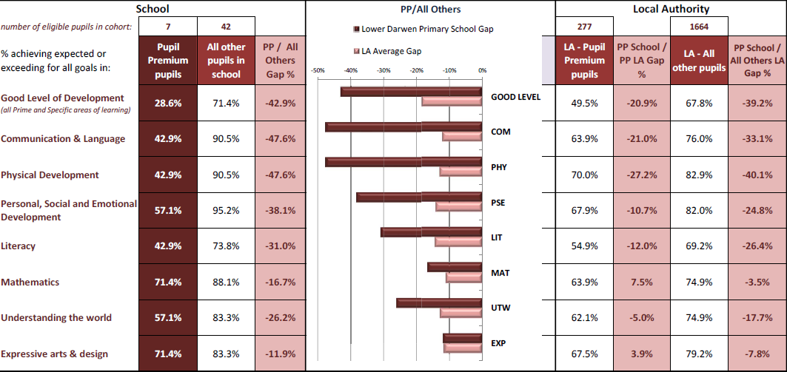Phonics
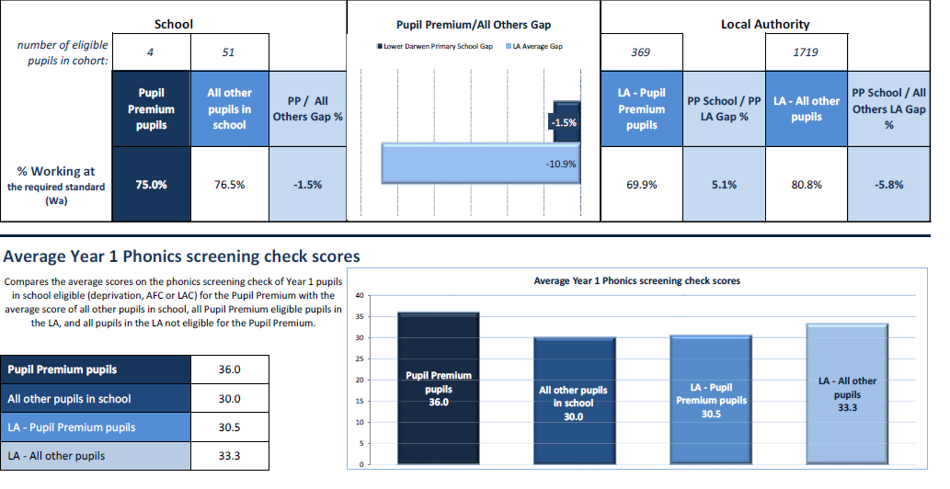

MTC
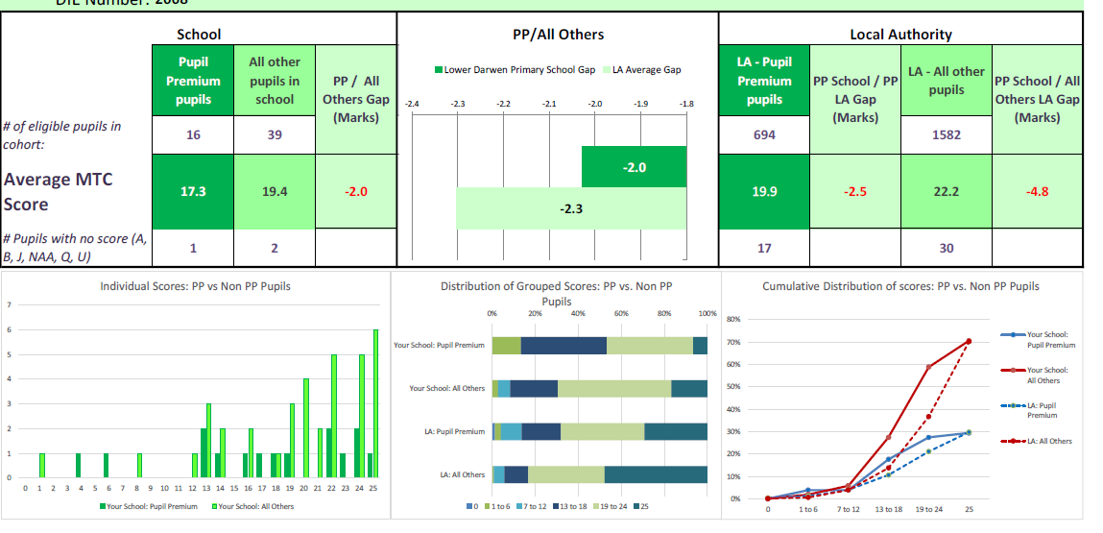KS2
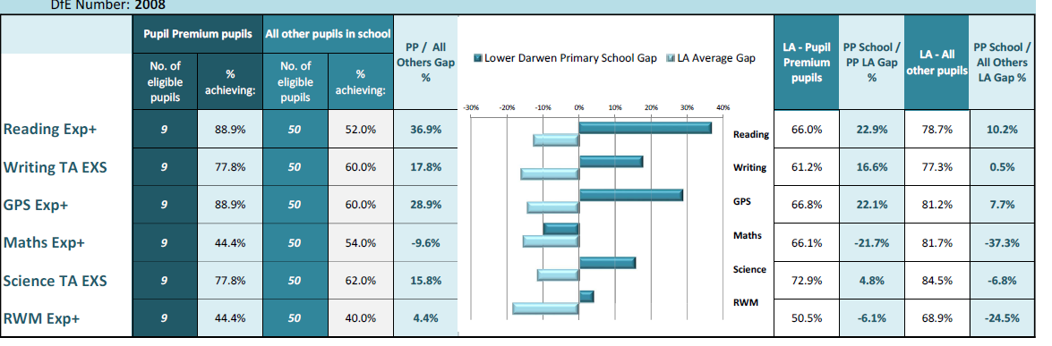

Further information (optional)
Use this space to provide any further information about your pupil premium strategy. For example, about your strategy planning, implementation and evaluation, or other activity that you are delivering to support disadvantaged pupils that is not dependent on pupil premium funding.

